**CHAPTER-1**

**1.1 INTRODUCTION**

The main objective of Skyline ERP is to make easy for faculty’s as well as students to coordinate with each other .It acts as a mediator between the faculty and students. Faculty can update any information and can chat with the registered student. It also view the students updates.

For the students also there are various modules helping them to upload documents and chat with the registered faculty. Every students and faculties has to login with their User Id and Password.

There are several modules that work once when the faculties or students is logged in. They can choose any of the component displayed and can avail the services according to their need.

User Id and Password is given to each faculty and students so that messaging system can recognizes them as user. Only users which is registered in this can get the services through this.

This web based system will provide better prospective for the enhancement of organisation regarding to quality and transparency.

Obtaining a User Id and Password. The User Id and Password being unique and auto generated. After they get there registration confirmed, he/she can avail any service according to requirements.

The project allows Hod to schedule a test specifying time and set of questions for the test. It would enable educational institutes to perform technical tests, aptitude tests and quiz. The result of the test would be immediately available to the student. Further the student can also check the wrong answers and their solutions after the test. The Hod can also upload related materials on the server which will be made available to the students for download. This project would be helpful for creating practice tests, say for educational institutes.

This project would be very useful for educational institutes where regular evaluation of students’ is required. Further it can also be useful for anyone who requires feedback based on objective type responses. Apart from this examination aspect, this project would be very useful for the placement department of the institutes to efficiently handle the student data in database that at present is maintained in the form of excel sheets manually.

Since this software is being designed to serve as one point solution to online examinations and online record maintenance, this software will also help institutes to maintain the records of students related activities like filtering of student data etc.

**1.2 ABOUT THE PROJECT**

For an organization to run successfully and efficiently it is very important that it have efficient worker and to use its resources very well specially human resource. So one of the most important goals of an organization is to recruit right candidate for right job.

The main object of Skyline ERP is to make easy for faculty as well as student to coordinate with each other. **It acts as a mediator**  between the **faculty and student**. It also view the student updates.

There are several modules that work once when the faculty or student is logged in. They can choose any of the component displayed and can avail the services according to their need.

It refer to instruction in a learning environment where teacher and student are separated by time or space, or both, and teacher provide course content. Student receives the content and communicates with the teacher **via chat technology.**

The Skyline ERP transcend the boundaries of location, times and space providing a flexible learning environment for all. **School, university and corporate organization** benefit from Skyline ERP because it provides an excellent way for expert to teach group of student.

**User id and password**  is given to each faculty and student so that messaging system can recognizes them as user . Only user which is register in this can get the services through this.

This project assesses students by conducting online objective tests. **The tests** would be highly customizable. This project will enable educational institutes to conduct test and have automated checking of answers based on the response by the candidates

**1.3 PROPOSED SYSTEM**

The major prospect of this project is to make JSP enabled applications which is HOD instructive based to provide the displayed services to the faculty and the students of the organisation.

* Responses by the candidates will be checked automatically and instantly.
* Online examination will reduce the hectic job of assessing the answers given by the candidates.
* Being an integrated Online Examination System and Online Communication faculty and students it will reduce paper work.
* Can generate various reports almost instantly when and where required.
* Help students assess their real potential.
* Maintain records of students’ performance.
* Provide downloadable materials to students for examination assistance.

**1.4 BENEFITS OF PROPOSED SYSTEM**

JSP which is the part of advance java has changed the world in the age of information technology in the arena of post globalization. Every user of an organisation should have access to the authorities. Using this application , individual user can then place their own requirements and hence can retrieve the needed sitting at their place. this project would be very useful for the placement department of the institutes to efficiently handle the student data in database that at present is maintained in the form of excel sheets manually.

**1.5 BACKGROUND ANALYSIS**

This project is developed for the organisation to save time. This project will be helpful for faculties as well as the students. It keep track of storage record and notice which are given by HOD, faculty and students. It also undertakes to manage the messaging between faculty and students on an outstanding basis.

Skyline ERP act like a mediator between registered faculties as well as the registered students of an organisation.

**1.6 OBJECTIVE AND APPLICATIONS OF THE PROJECT**

The objective and application of the project is to completely automate the following processes:

* The main objective of the project is to establish a network among all the faculty and student operating in all over the organisation. All the information can easily accessed and shared among them.
* This system act as an intermediate between the registered faculty and the registered student of an organisation.
* HOD is allowed to register any new user. For the user there are various modules helping them for communicating and changing of information.
* User Id and Password is given for each user through which they login and use the services provided to them.
* This system provides the organisation to transfer information or the file between the faculty and student.
* Being an integrated Online Examination System it will reduce paper work.
* Can generate various reports almost instantly when and where required.
* Help students assess their real potential.
* Maintain records of students’ performance.
* Provide downloadable materials to students for examination assistance.

This site also helps the user to communicate with each other’s with the help of messaging services given to them. and online tests like aptitude G.K and technical exam.

**CHAPTER-2**

**2.1 TECHNOLOGY USED**

The technology used in this project both at front end as well as back end. On the front end, “NetBeans IDE 8.2” has been used and at the back end, “MySQL Workbench 6.3ce” is used.

* Application Architecture - J2EE
* Application Architecture version - JAVA EE8
* Database Application - MySQL
* Development tool - Rational System Developer.
* Web Application Resource - WAR.
* Application Server - Glassfish

**2.2 FRONT END**

Our project “Skyline ERP” is based on all the tools that are available in “JSP”. All the tools that are used in this project are used to their best extent. All these tools make our project easily modifiable, easily understandable and give our project a good view. we used html, , JavaScript and bootstrap to design the front end of the project.

The most important tools that we used in our project is connectivity that helps us to connect the different tables that are used to source data that we want to use in our project or we have used in our project. The most important property of property of this connectivity is that we can use different of cursor such as the cursor that are only used to move forward and next record, cursor that are used to edit/update, read record etc.

It is in NetBeans8.2 Integrated Development Environment (IDE) from “Oracle Corporation”. It can be used to develop console and user graphic interface application along with the Windows Forms Application, web sites, web application and web services in both native code to gather with managed code for all platforms supported by “Oracle Corporation” i.e. NetBeans8.2 Integrated Development Environment (IDE).

NetBeans 8.2 include a code editor supporting intelligence as well as code refactoring. The integrated debugger works both as a source-level debugger and a machine-level debugger. Other built-in tools forms designer for building GUI applications , Web designer, ERP Designer, and Data Base Scheme. The FRONT END is basically designed on XML/HTML, CSS, JavaScript, and Bootstrap.

**2.3 BACK END**

* **MySQL SERVER**

The Backend we have used in our project “SKYLINE ERP” in MySQL Server. The reason of its usage is that MySQL Server have better connectivity then MS Access. That is the most commendable reason for its usage. Another reason for its usage is we feel much easier to create table, views in MySQL Server. It is pretty much easier to update the table through command typed in NetBeans.

MySQL Server made it very easier for us to use data in the table also we fell very easier to easier to store data through commands. MySQL Server.

**2.4 SOFTWARE REQUIREMENT**

* **Operating System:**  Windows 7 and above OR Linux
* **Development Environment :** NetBeans IDE 8.2 ,Glashfish
* **Database Server:** MySQL Workbench 6.3CE
* **Languages Used:** Html, C.S.S , JavaScript, Bootstrap, Advance Java
* **Word Processor:** Microsoft Word 2016
* **Image Processing Tool:** Photoshop
* **Web Browser:** Google chrome

**2.5 HARDWARE REQUIREMENT**

* **Microprocessor:** 86 Family 6 Models 8 Stepping 6 GenuineIntel~930 MHZ.
* **RAM:**1 GB
* **Hard Disk Space Required:**  2 GB
* **Hard Disk Drive:** 40GB
* **Visual Display Unit:**HCL-56V
* **DVD W/R:** CD ROM sc-152c.

**CHAPTER-3**

**3.1 SYSTEM DEVELOPMENT LIFE CYCLE**

System Development Life Cycle (SDLC) is a process used by system analyst to develop an information system , including requirements, validation, training and user (stakeholder) ownership. Any SDLC should result in a high quality system that’s meets or exceeds customer expectations , reaches completion within time and cost estimate work effectively and efficiently in the current and planned information Technology infrastructure and is inexpensive to maintain and cost-effective to enhance.

Computer system are complex and often (especially with the recent rise of Service-Oriented Architecture) link multiple traditional system potentially supplied by different software vendors. To manage this level of complexity, a number of SDLC models of methodologies have been created, such as “Waterfall” , “Spiral” , “Agile” , “Rapid Prototyping” , “incremental” , and “Synchronize” and “stabilize”.

SDLC models can be described along a spectrum of Agile to iterative to sequential Agile methodologies such as XP and scrum focus on lightweight process which allow for rapid changes along the development cycle. Iterative methodologies, such as Rational Unified Process and Dynamic System Development Method, focus on limited project scope expending and improving products by multiple iterations. Sequential or Big-design-Up-Front (BDUF) such as Waterfall , Focus on complete and correct planning to guide large project and risk to successful and predictable results. Other models, such as Anamorphic Development, tend to focus on a form of Development that is guided by project scope and adaptive iterations of feature development.

In a project management project can be defined as both with a Project Life Cycle (PLC) and a SDLC, during which slightly different activates occur According to Taylor in 2K04 “The project Life cycle encompasses all the activates of the project , while the system development cycle focusing on realizing the product requirements”.

**3.2 PROBLEM DEFINITION OR IDENTIFICATION**

It is vital to understand the each and every aspect project. So as soon as the project was allocated, we carefully went through the project to identify the requirement of project

**3.3 MODULES**

This project contains six modules.

* Student registration form.
* Faculty registration form.
* HOD manages complete system.
* Chat sessions between student and faculty.
* Online test for G.K, Technical, Aptitude
* Online test for Result reviews

***3.3(A) STUDENT REGISTRATION***

In this module we describe the student registration form. The registration form will be placed on the site. Students will fill the form online at the site and those form will be send to HOD. The registration forms will be store in the database by the HOD. Students need to provide their email id and password.

***3.3(B) FACULTY REGISTRATION FORM***

In this module we describe the faculty registration form. The form will be placed on the site. The Faculty members can register themselves same as students. The registration form of faculty members will be send to HOD. The registration form will be stored in the database by the HOD.

***3.3(C) HOD MANAGES COMPLETE SYSTEM***

In this module we describe about the HOD managing the complete system. Following are the functions executed by the HOD-:

* Create Database.
* Manages and Modifies the Database.
* Publish important information.
* Manages the backend of the site.
* Create Question test

***3.3(D) CHAT SESSIONS***

In this module we describe the chat sessions between the students and faculty. Students can chat with corresponding Faculty members about the queries they are facing. This is very helpful in saving time for both the students as well as faculty members.

***3.3(E)***  ***ONLINE TEST***

The project allows HOD to schedule a test specifying time and set of questions for the test. It would enable educational institutes to perform technical tests, aptitude tests and quiz. The result of the test would be immediately available to the student. Further the student can also check the wrong answers and their solutions after the test

***3.3(E)***  ***RESULT REVIEWS***

to online examinations record maintenance, this software will also help institutes to maintain the records of students for placement related activities like filtering of student data etc.

**3.4 SYSTEM ANALYSIS**

Requirements analysis is a software engineering task that bridges the gap between system level requirements engineering and software design. Requirements engineering activities result in the specification of the software’s operational characteristics (function, data and behaviour), indicate software’s interface with other system elements and establish constraints that software must meet. The most commonly used requirement technique is to share the information between the faculty members and students.

The system refers to instruction in learning environment where teacher and student are separated by time or space or both and teacher provides notice to students and vice-versa. This site act as mediator between the teacher and students where the students and teachers can interact with each to solve queries and provide solutions to the students.

**3.5 FEASIBILITY STUDY**

Feasibility is conducted to select the beast system that meets the performance requirements. This entails an identification, description, and evaluation of the student and faculty interaction.

Many feasibility studies are disillusioning for both user and analyst. First, the study often pre-supposes that when feasibility of the documents is being prepared, the analysis is in position to evaluate solutions. Second most studies tend to overlook the confusion inherent in the system development. If the feasibility study is to serve as decision document, it must answer three key questions:

* Is there new and better way to do the job that will benefit the organization?
* What are the cost and saving of the alternatives?
* What is recommended?
* To analyze whether the software will meet organizational requirements
* To determine whether the software can be implemented using the current technology and within the specified budget and schedule
* To determine whether the software can be integrated with other existing software.
* Analyzes the technical skills and capabilities of the software development team members
* Determines whether the relevant technology is stable and established
* Ascertains that the technology chosen for software development has a large number of users so that they can be consulted when problems arise or improvements are required.

**3.6 DATA FLOW DIAGRAM (DFD)**

The data flow diagram depict the flow of the information within the system. The system and its user act as sink with all the information following into them. Client act the source as all the request are generated by him. Arrows within the DFD show the flow of the information from one processing point to another.

DFD is quit important as it record in pictorial from all the information flow within the system. With the help of DFD we can identify the current information structure of the system. We can group the system more efficient.

The DFD is intended to represent information flow but it is not a flowchart and is not intended to indicate decision making, flow of control, loops and other procedural aspect of the system. DFD is a useful graphical tool and is applied at the earlier stages of requirement analysis. It may be further refined at preliminary design stage and is used as mechanism for creating a top level structural design for software.

A DFD provides no information about the timing of processes, or about whether processes will operate in sequence or in parallel. It is therefore quite different from a flowchart, which shows the flow of control through an algorithm, and under what circumstance, but not what kinds of data will be input to and output from the system, nor where the data will come from and go to, nor where the data will be stored (all of which are shown on a DFD)

**Level 0 DFD**

Database

Authentication

Login

Mediator

**Level 1 DFD**

1. chat with student

2.upload notices

3 review student upload

View his AD

2 Query

Matches to Query

**Level 2 DFD**

1. Dataset Collection

Notices Analysis

Exams Analysis

Data Base

2. Dataset

faculty

student

question

3 update

Edit faculty

Edit student

Edit question

4 Query

Reviews

Student

**Level 3 DFD**

1. type query

HOD notices

Faculty notes

Faculty message

Online test

2 View Details

Get Information

2 result

View Answer with related Information

**ANALYSIS AND DESIGN**

**3.6.1.1 USE CASE OVERVIEW:**

LOGIN

NOTICES

****ADD STUDENT

ADD NOTICES

ADD FAULTY

****FACULTY ADD QUESTUION

ADD FILE,NOTES

EDIT STUDENT

EDIT FACULTY STUDENTS

****EDIT NOTICES

INSTRUCTION EXAM

ADMIN(HOD) VIEW SCORE

GIVE TEST

EDIT QUESTION

CHAT

**3.6.1.2 REGISTER USE CASE :**

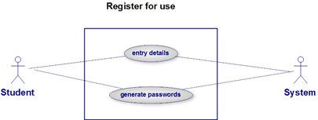

**3.6.1.3 LOGIN USE CASE :**

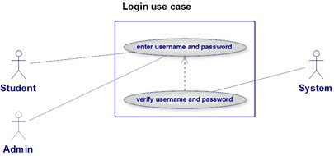

**3.6.1.4 VIEW TEST RECORDS USE CASE :**

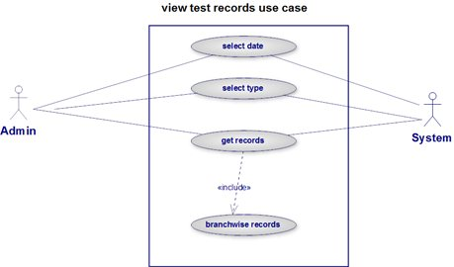

**3.6.1.5 ADD/DELETE QUESTIONS USE CASE :**

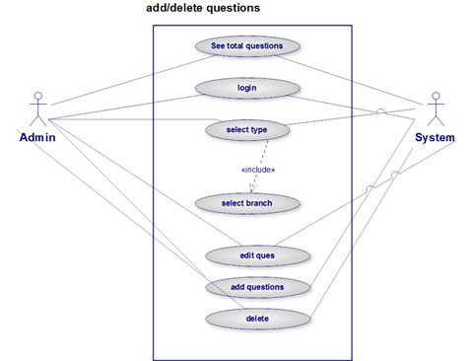

**3.6.1.6 EDIT USER PROFILE USE CASE :**

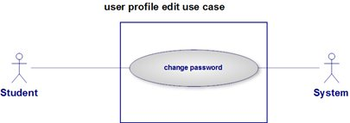

**3.6.1.7 TEST SETTINGS USE CASE :**

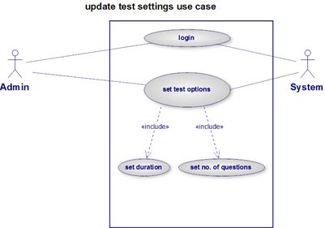

**3.6.1.8 GIVE TEST USE CASE :**

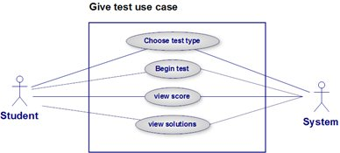

**3.6.1.9 UPLOAD FILE USE CASE :**

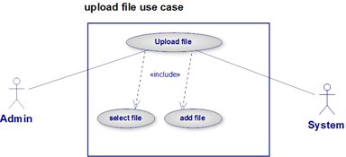

**3.6.2 ACTIVITY DIAGRAM :**

**3.6.2.1 LOGIN ACTIVITY DIAGRAM :**

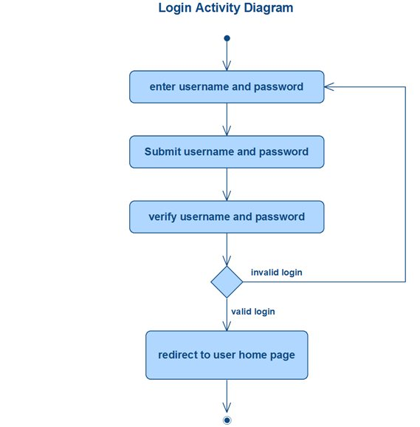

**3.6.2.2 SCHEDULE A TEST ACTIVITY DIAGRAM :**

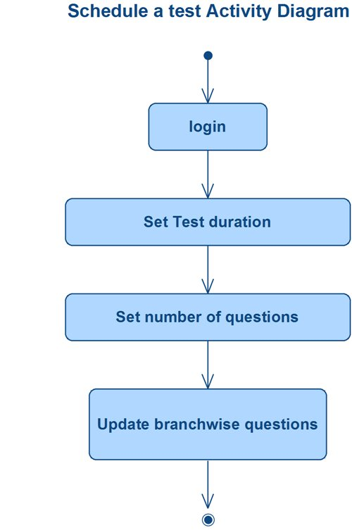

**3.6.2.3 VIEW SOLUTIONS ACTIVITY DIAGRAM :**

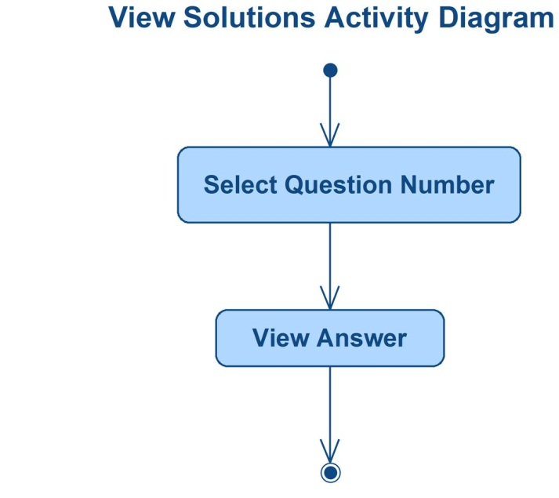

**3.6.2.4 ADD/EDIT QUESTIONS ACTIVITY DIAGRAM :**

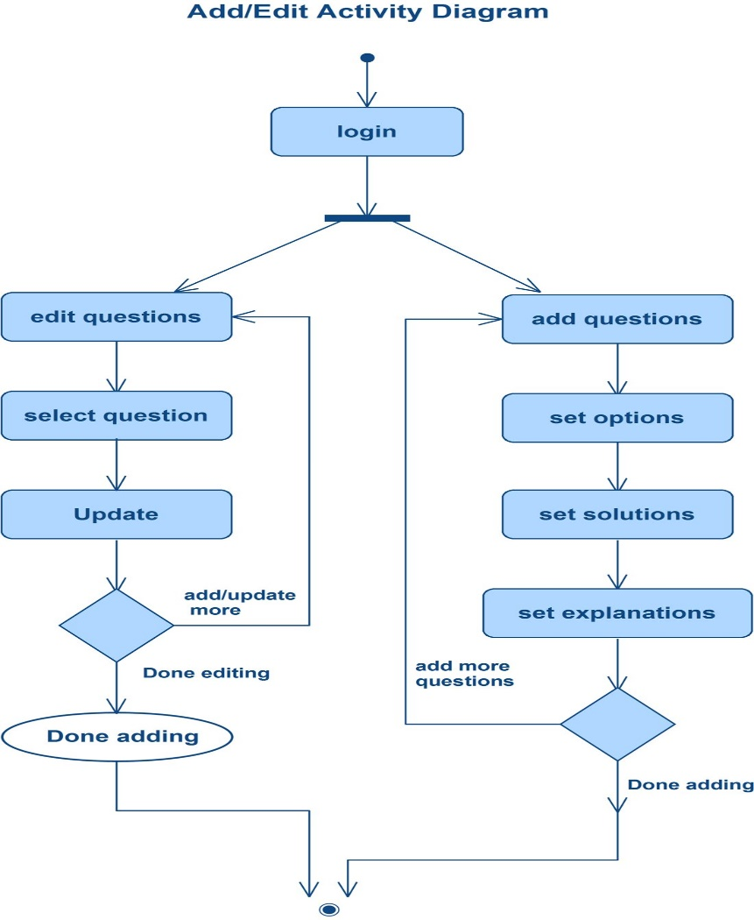

**3.6.2.5 SELECTING QUESTIONS FOR A TEST ACTIVITY DIAGRAM :**

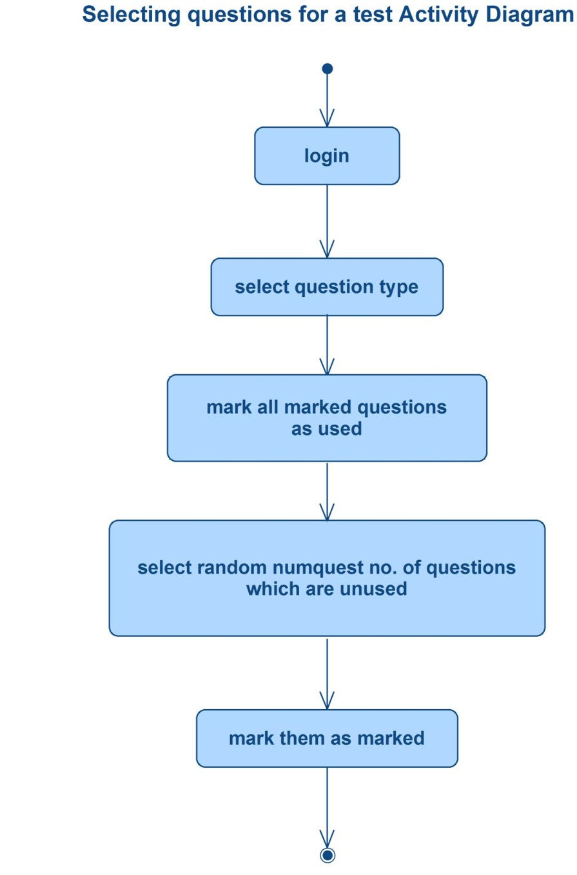

**3.6.2.6 GIVE TEST ACTIVITY DIAGRAM :**

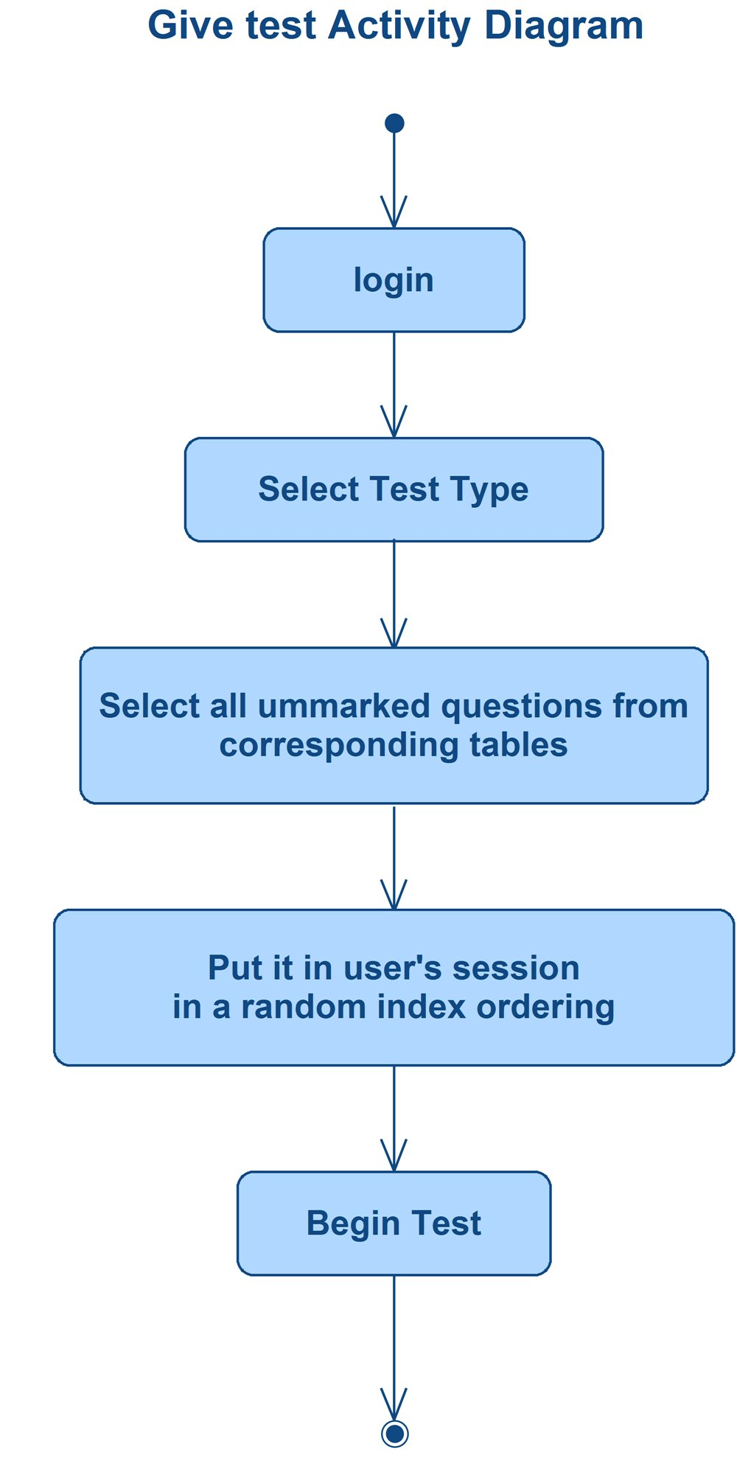

**3.6.2.7 GENERATE RESULT ACTIVITY DIAGRAM :**

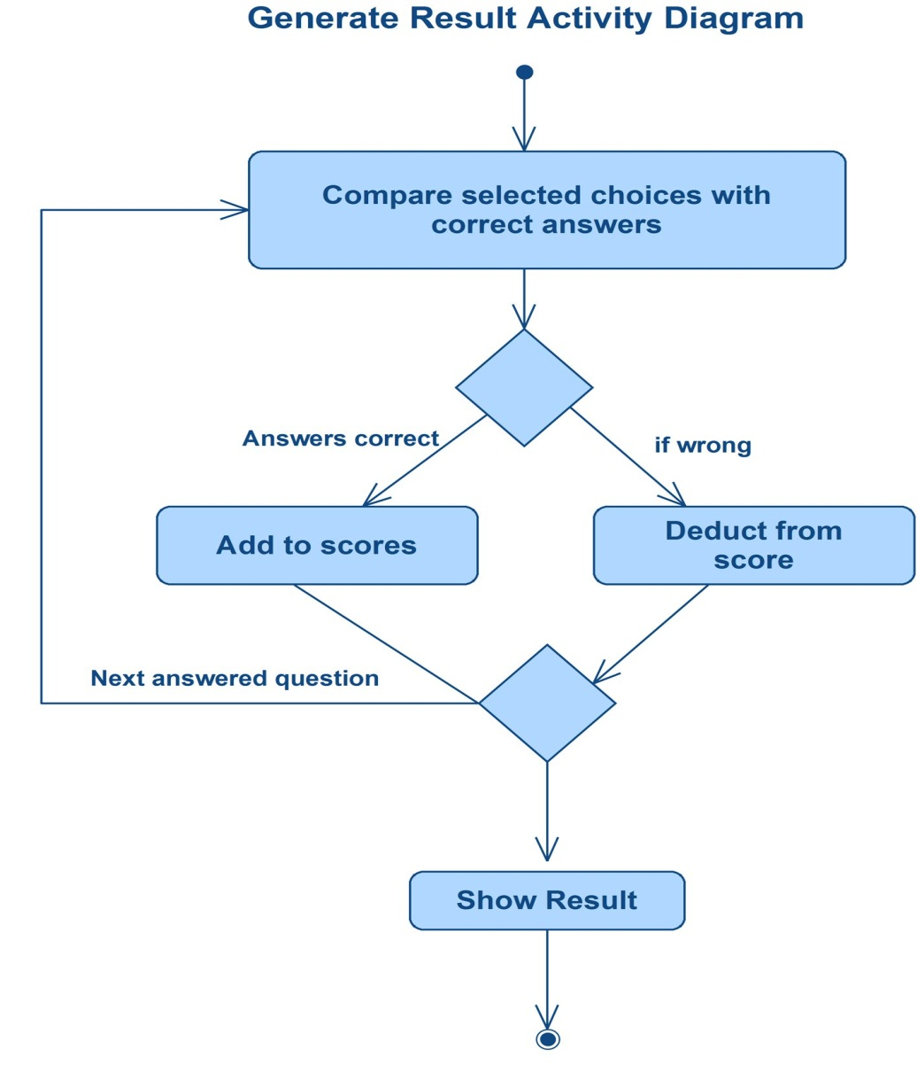

**3.6.3 SEQUENCE DIAGRAMS :**

**3.6.3.1 SEQUENCE DIAGRAM OVERVIEW :**

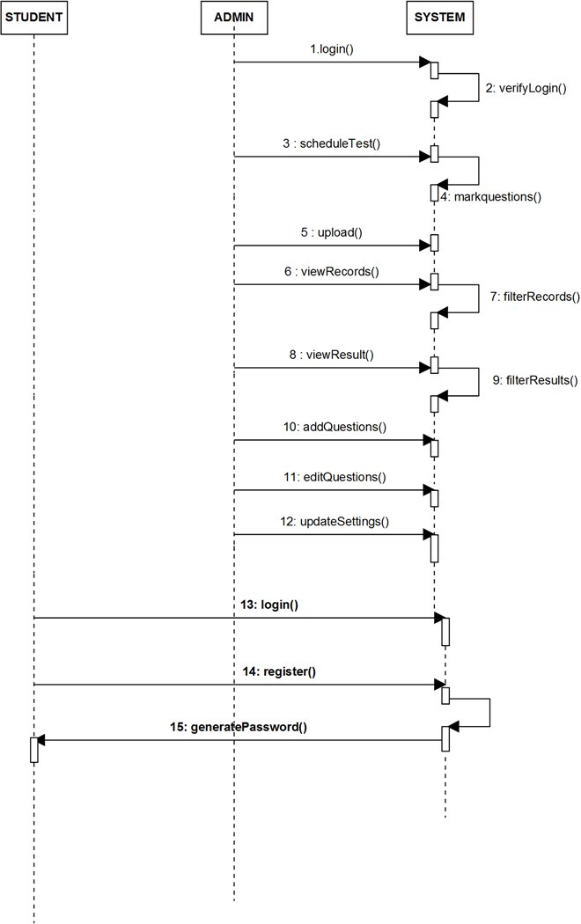

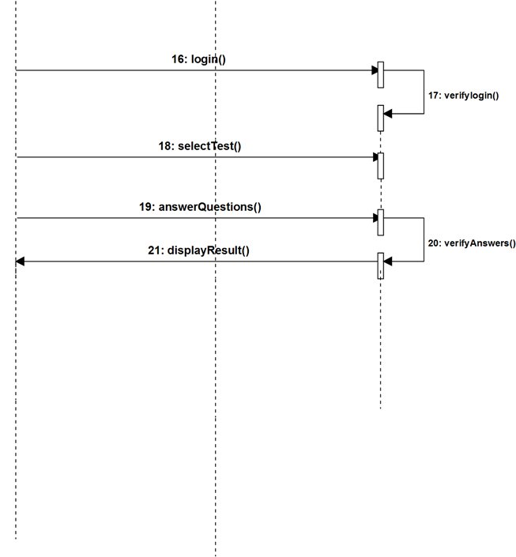

**3.6.3.2 SCHEDULE TEST SEQUENCE DIAGRAM :**

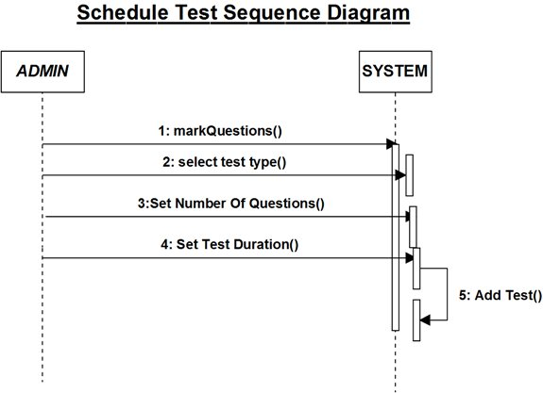

**3.6.3.3 ADD QUESTIONS SEQUENCE DIAGRAM :**

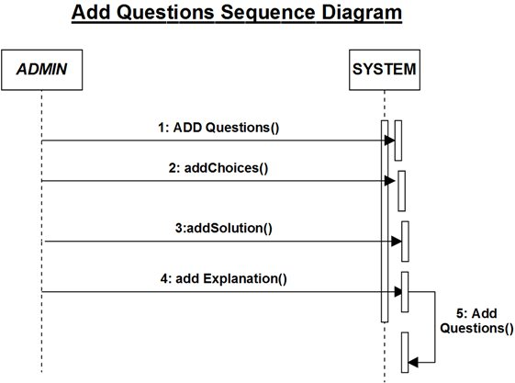

**3.6.3.4 APPEAR FOR TEST SEQUENCE DIAGRAM**

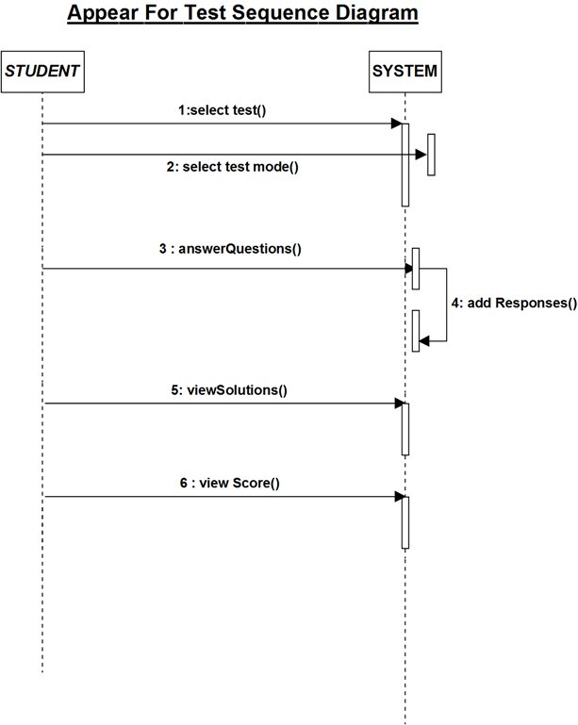

**3.6.3.5 LOGIN SEQUENCE DIAGRAM :**

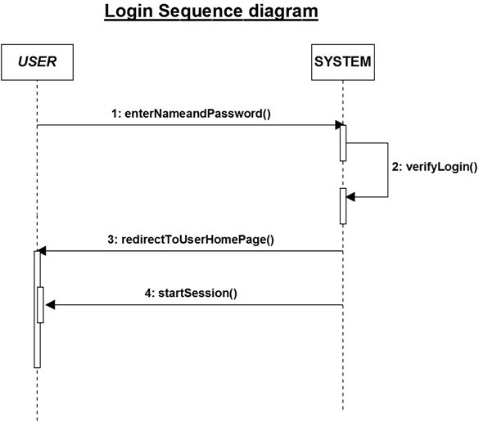

**3.6.3.6 STUDENT REGISTRATION SEQUENCE DIAGRAM :**

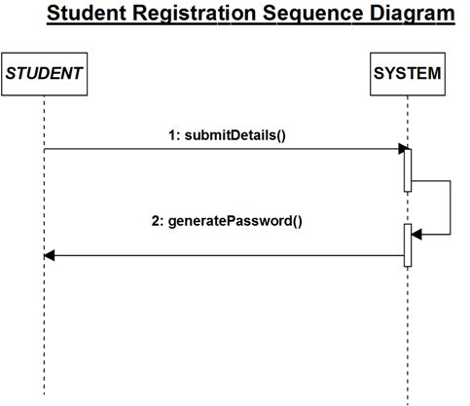

**3.6.4 DATABASE DESIGN (E-R DIAGRAM) :**

**3.6.4.1 ENTITY-RELATIONSHIP DIAGRAM:**

EC

EN

MCA

Aptitude

CIVIL

MBA

**Questions**

adds

Login info

Test settings

Sets

**HOD**

Login info

**TESTSCORES**

Test score

Login info

**STUDENT**

Notices board

Notices

Uploads

**Chat**

**Faculty**

**FILES**

adds

ME

CS_IT

**3.7 SCREEN LAYOUTS AND DESCRPTION**

***3.7(A) DATA TABELS***

* ***HOD***

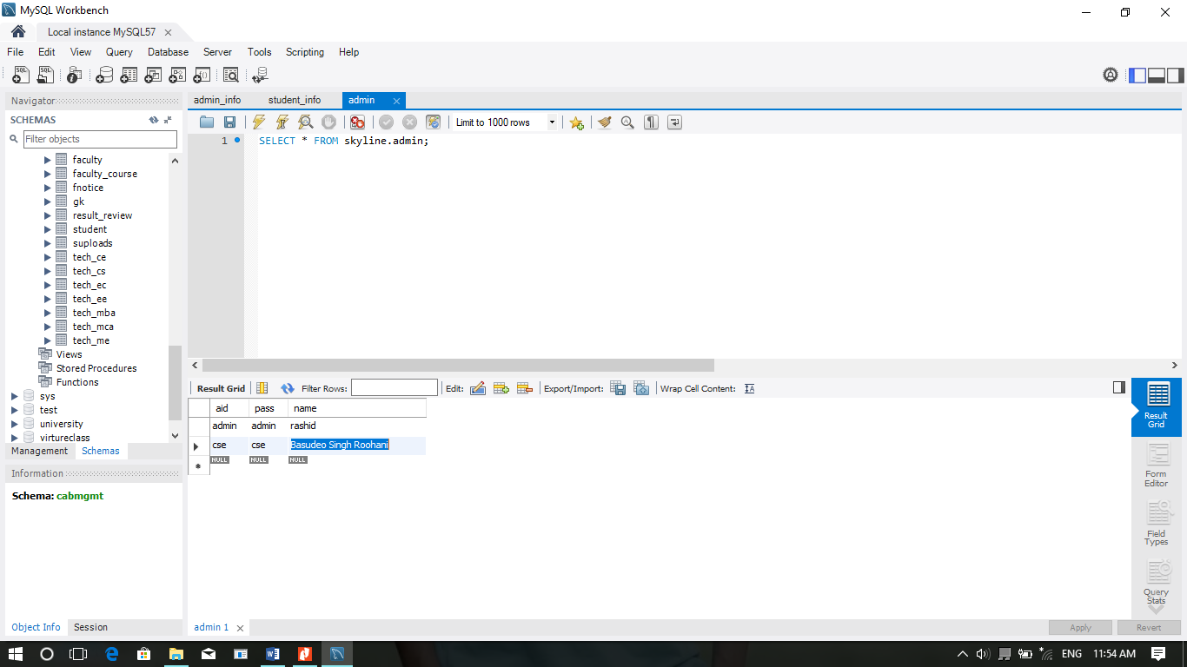

* ***FACULTY***

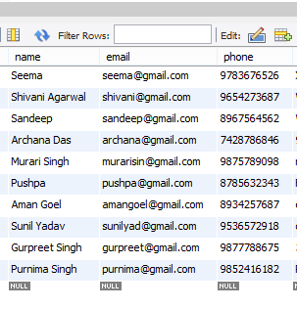

* ***FACULTY COURSES***

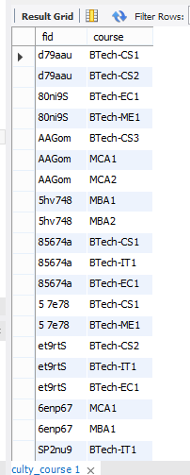

* ***STUDENT***

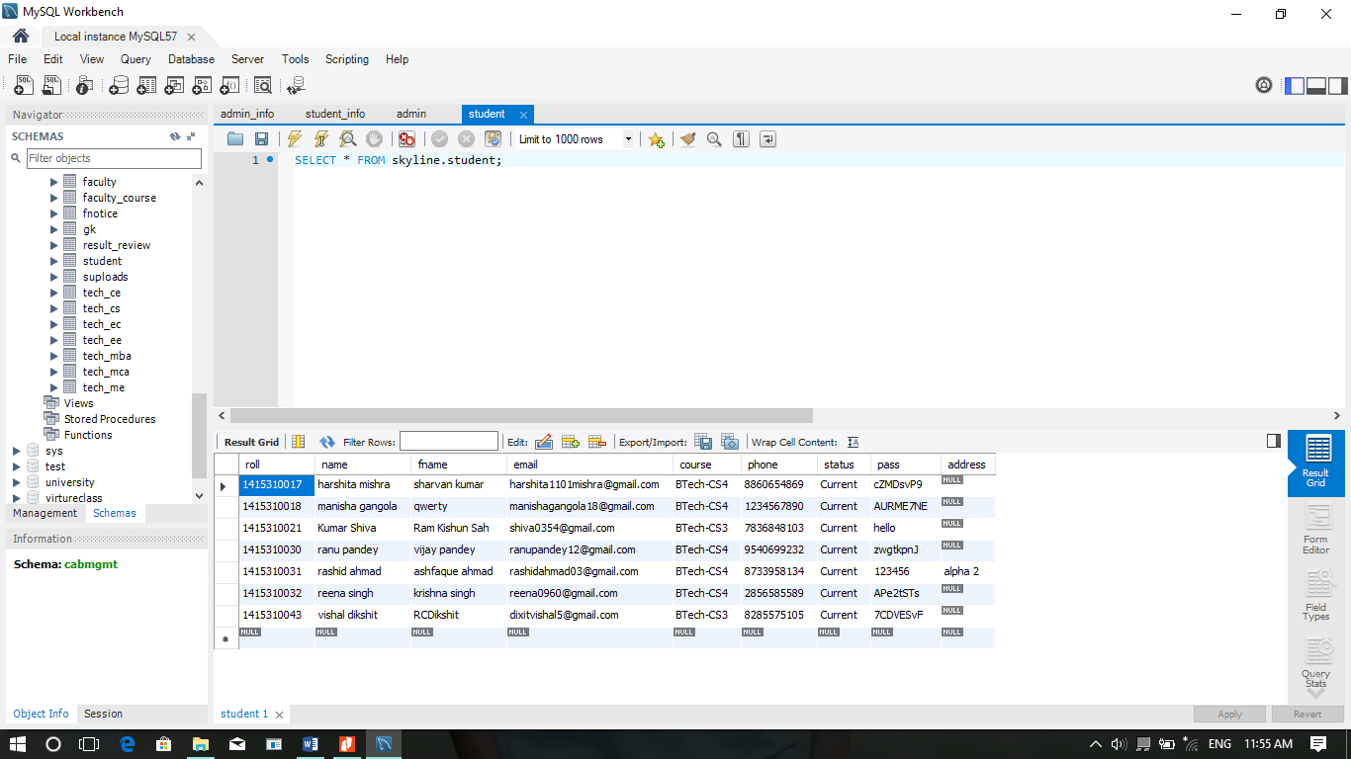

**3.7(B) SCREEN LAYOUTS WITH SNAPSHOTS**

* HOME PAGE

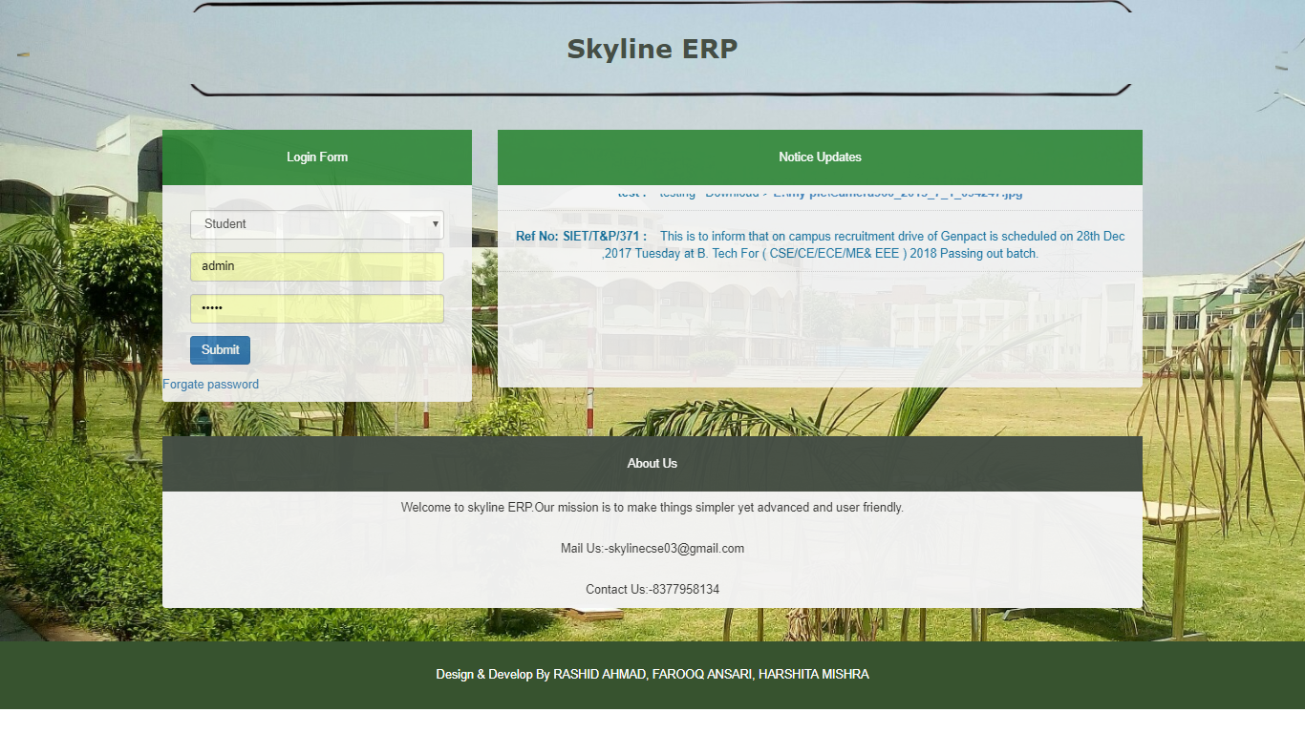

* HOD HOME PAGE

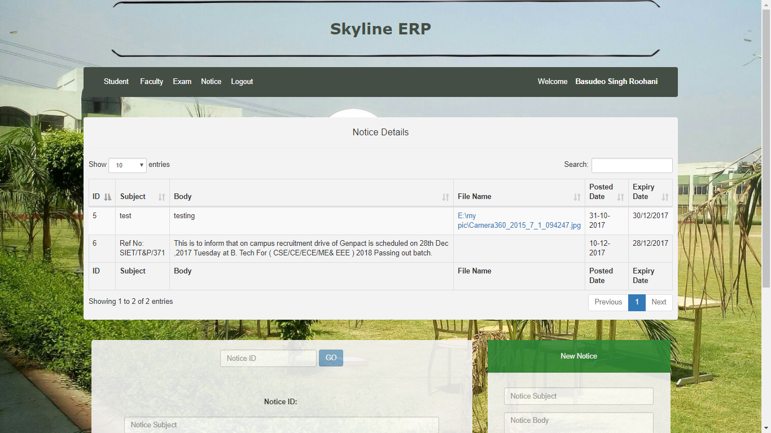

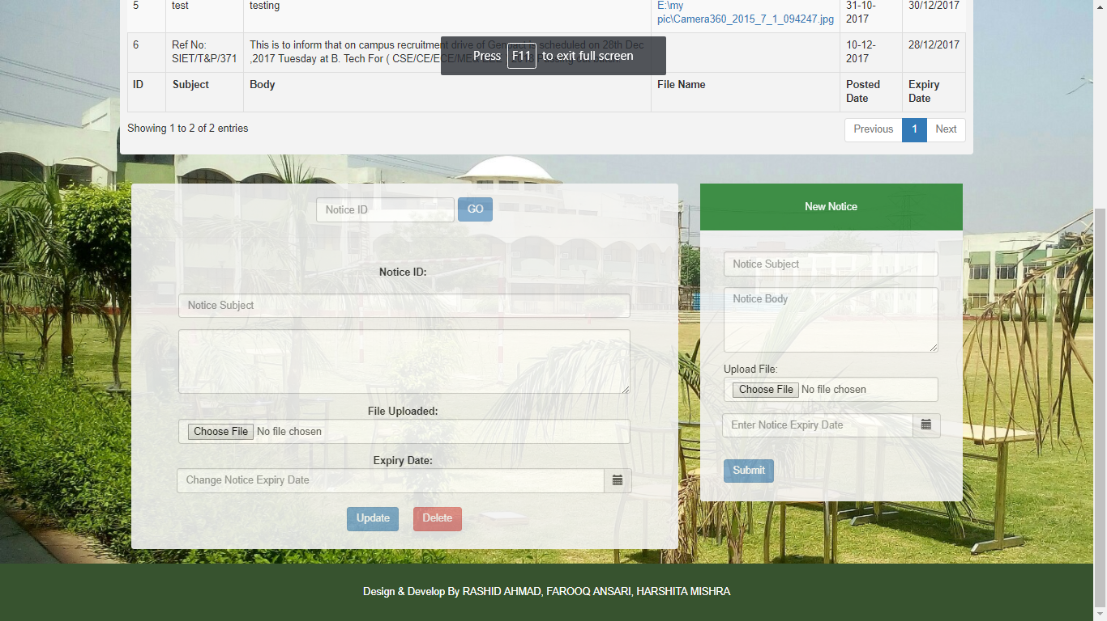

* HOD STUDENT SECTION

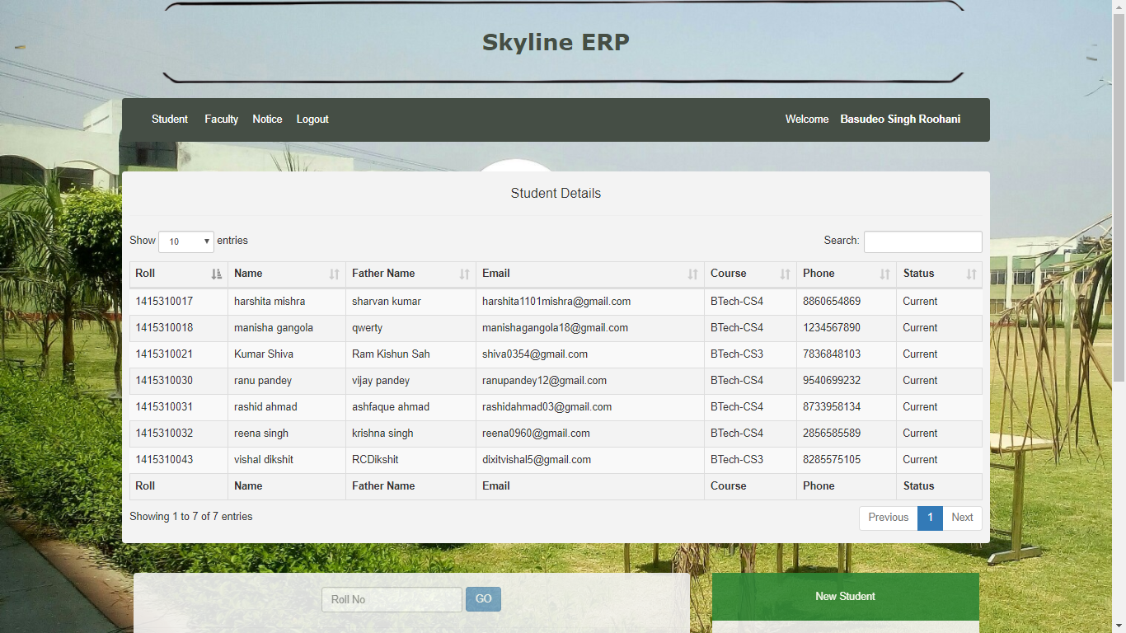

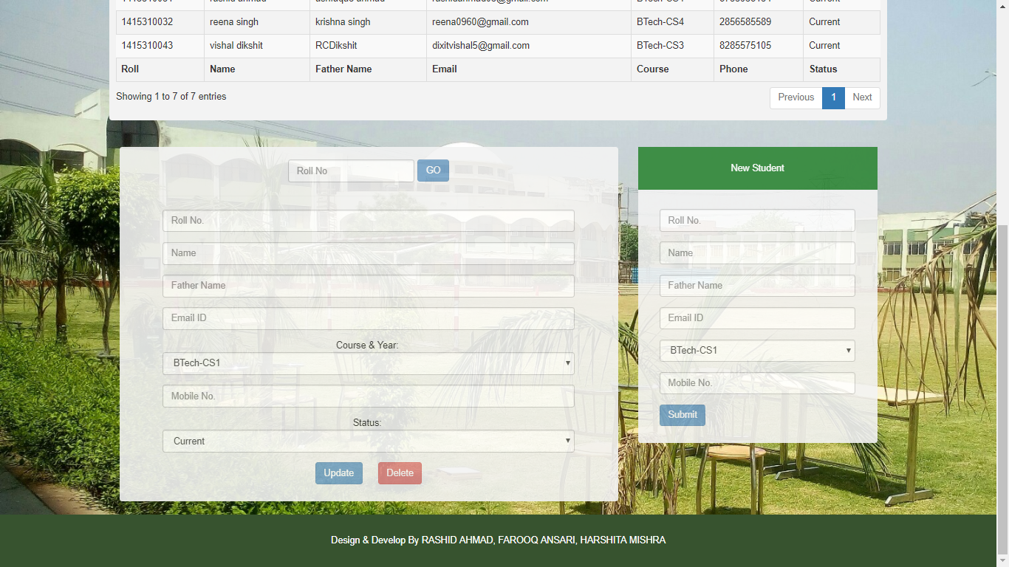

* HOD FACULTY SECTION

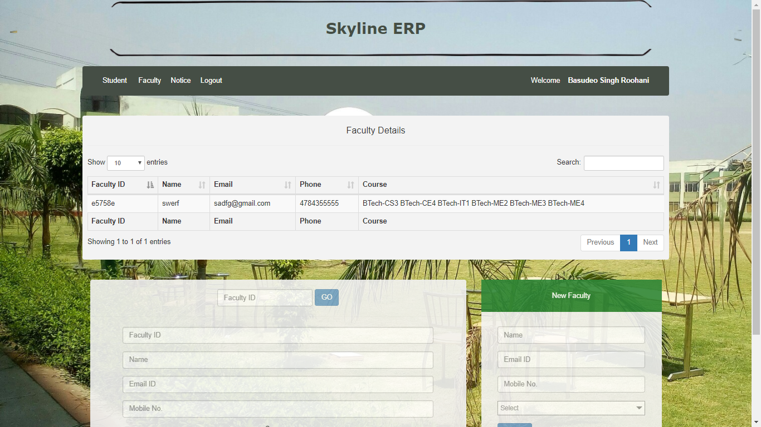

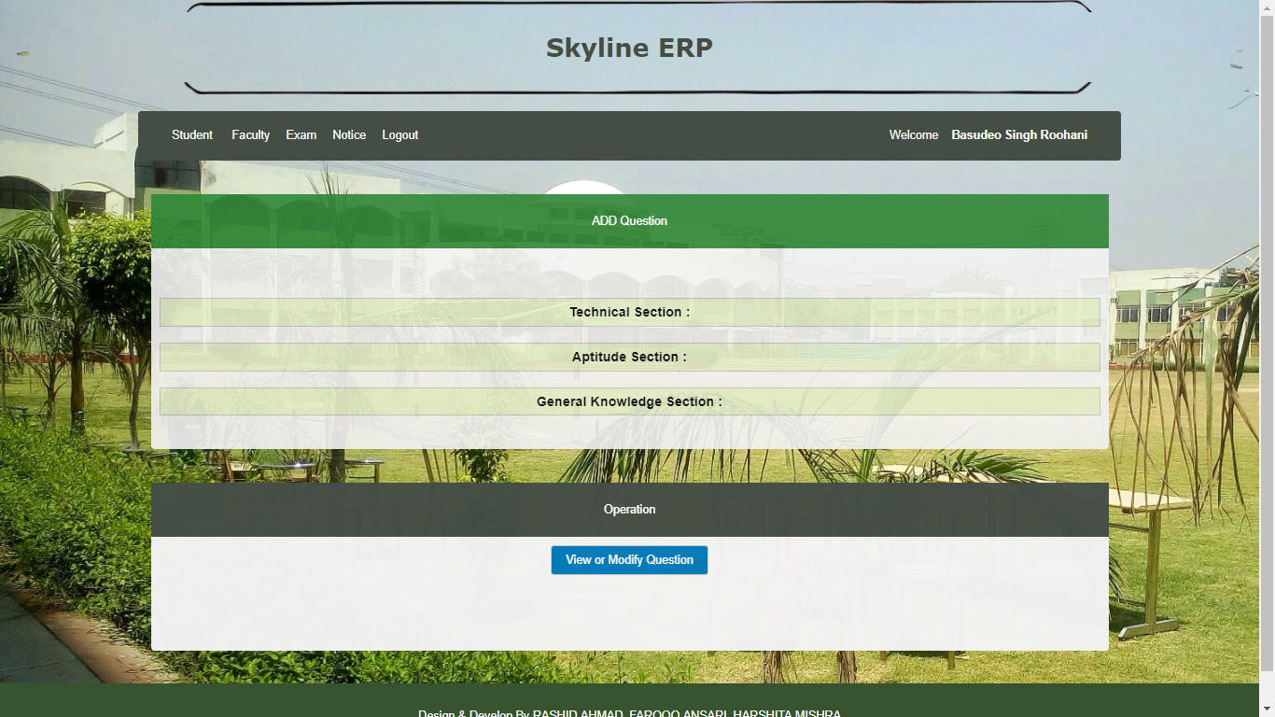

* HOD EXAM SECTION

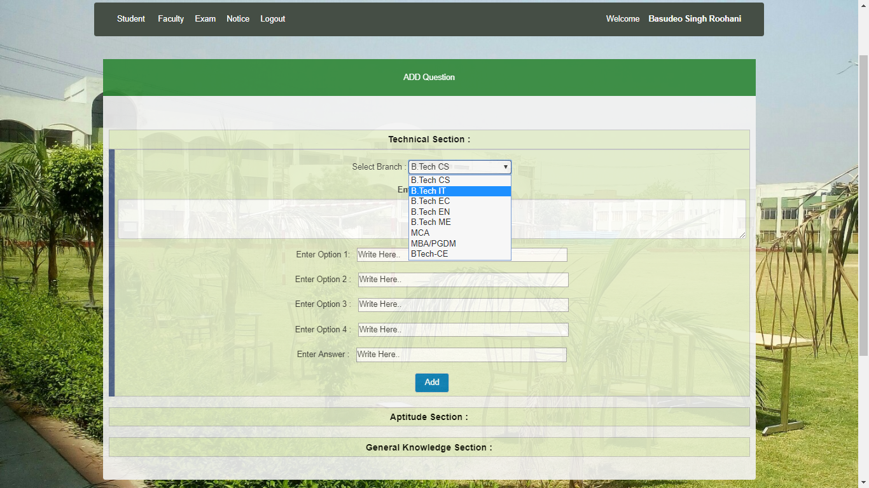

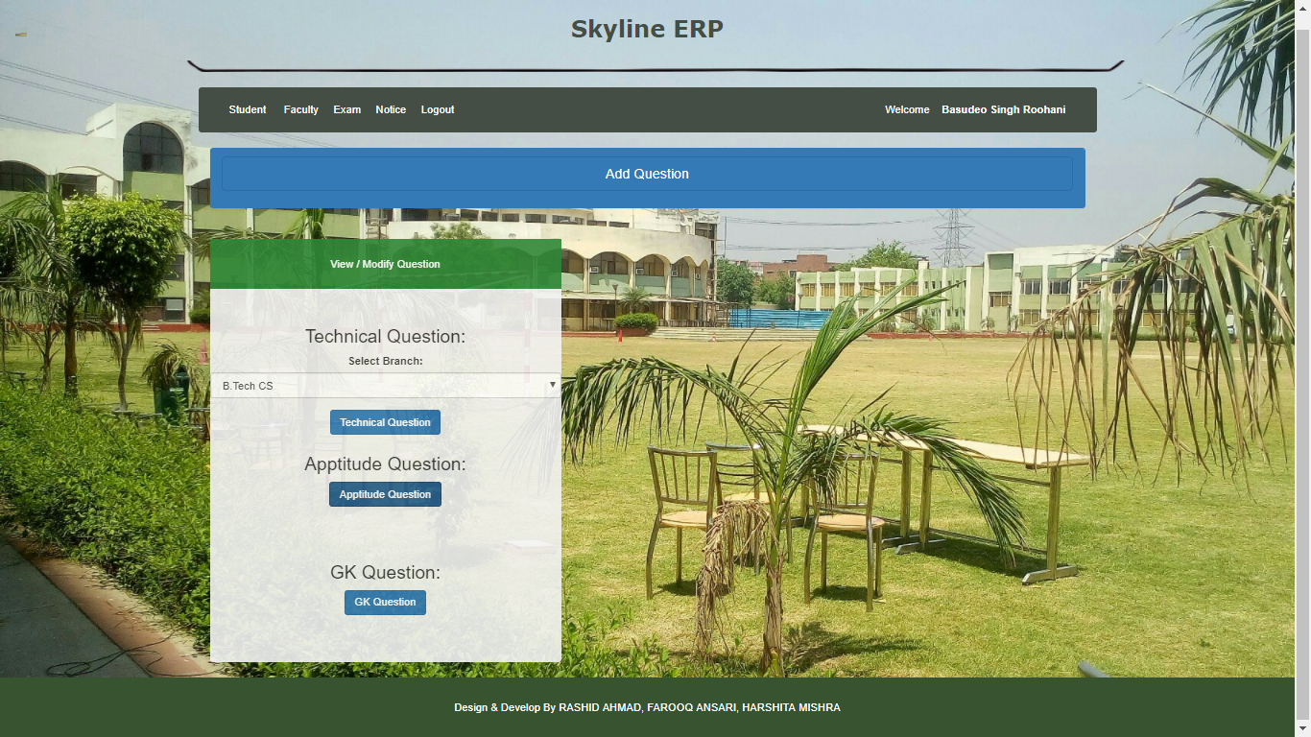

* HOD EDIT QUESTION SECTION

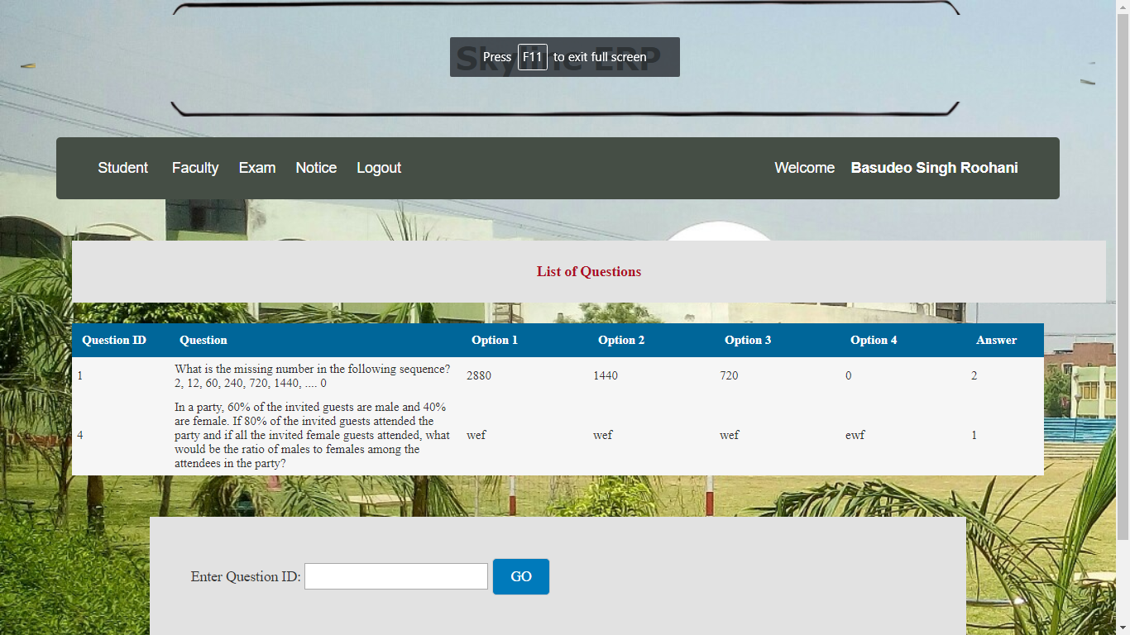

* FACULTY HOME PAGE

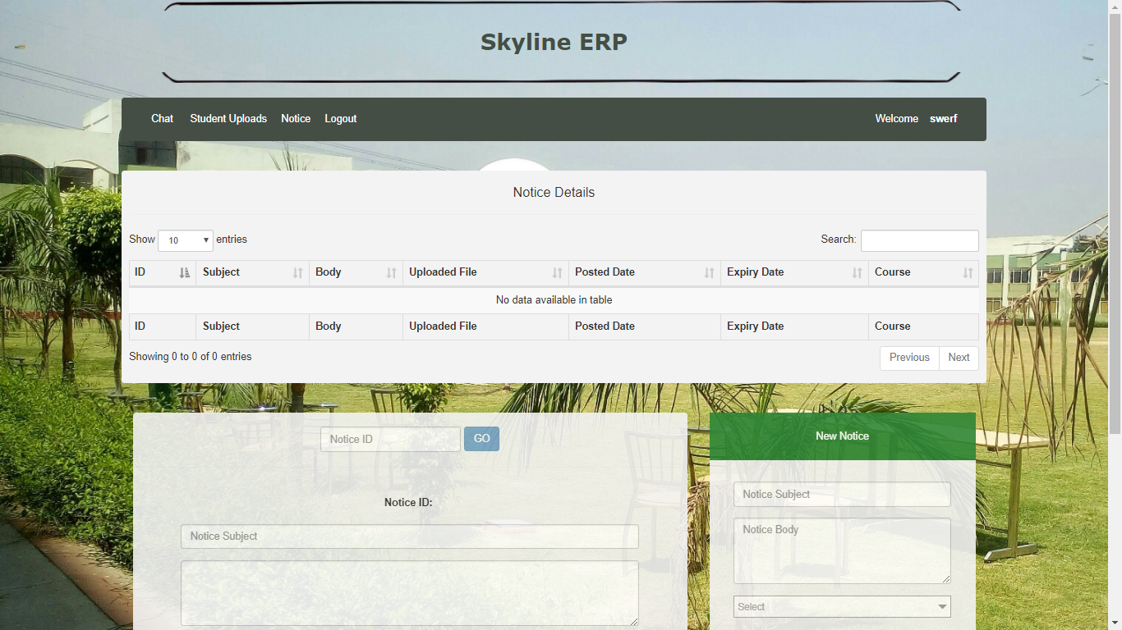

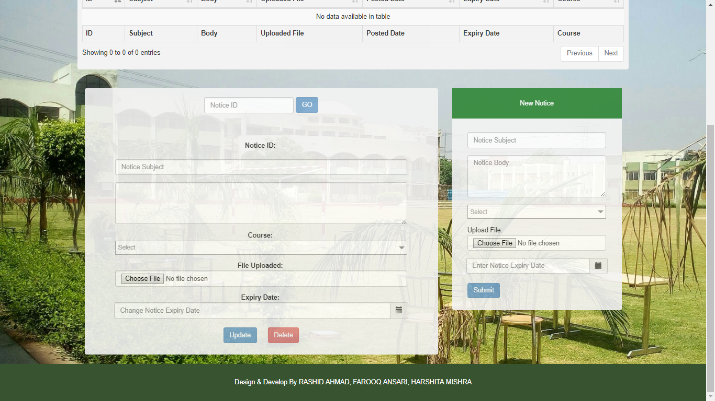

* FACULTY CHAT SECTION

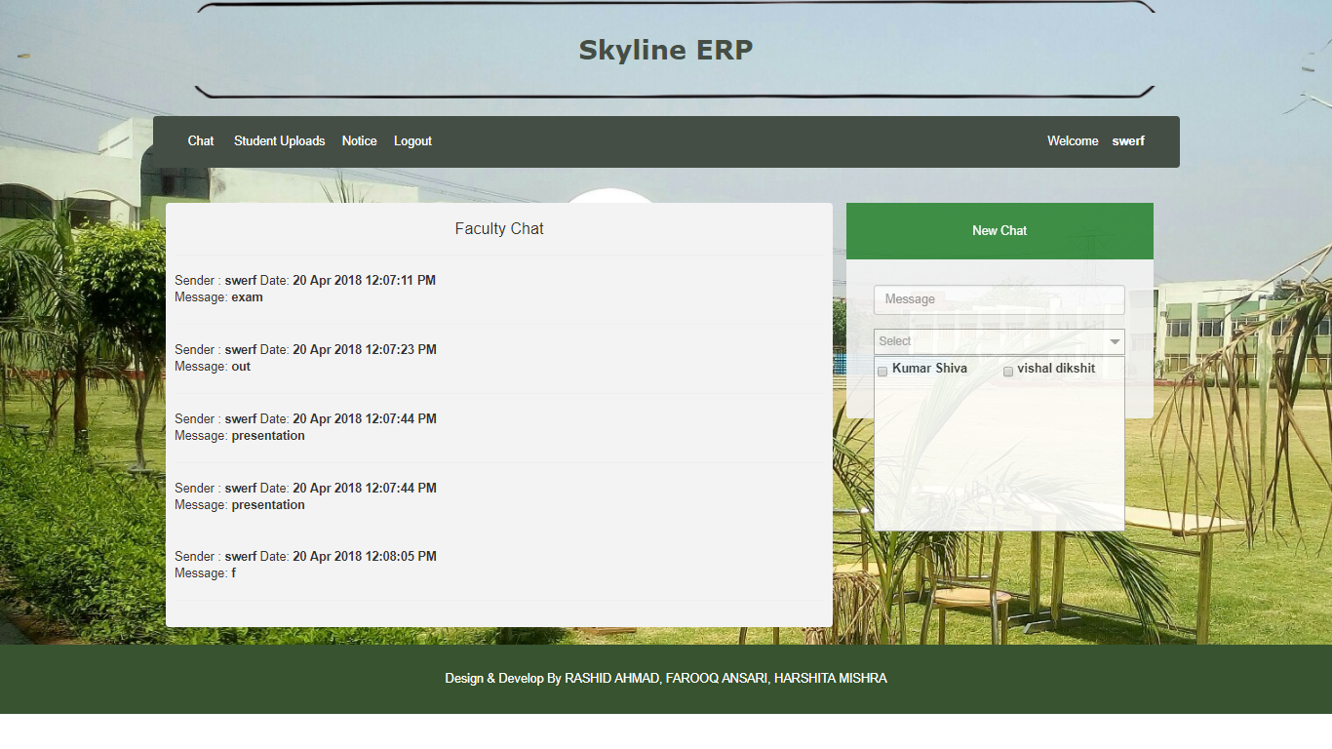

* STUDENT HOME PAGE

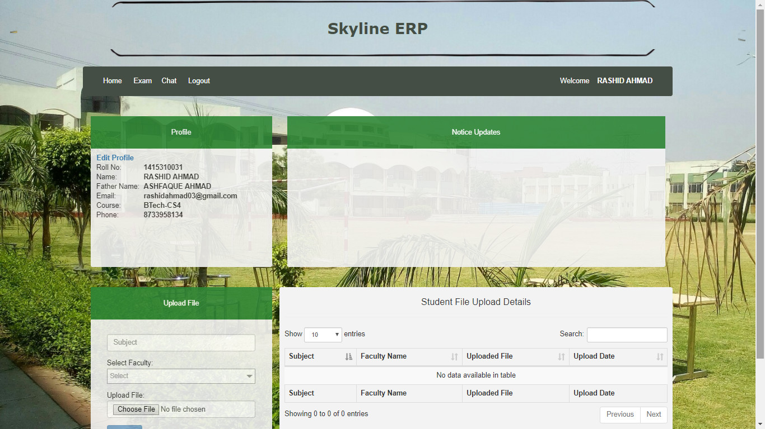

* STUDENT CHAT SECTION

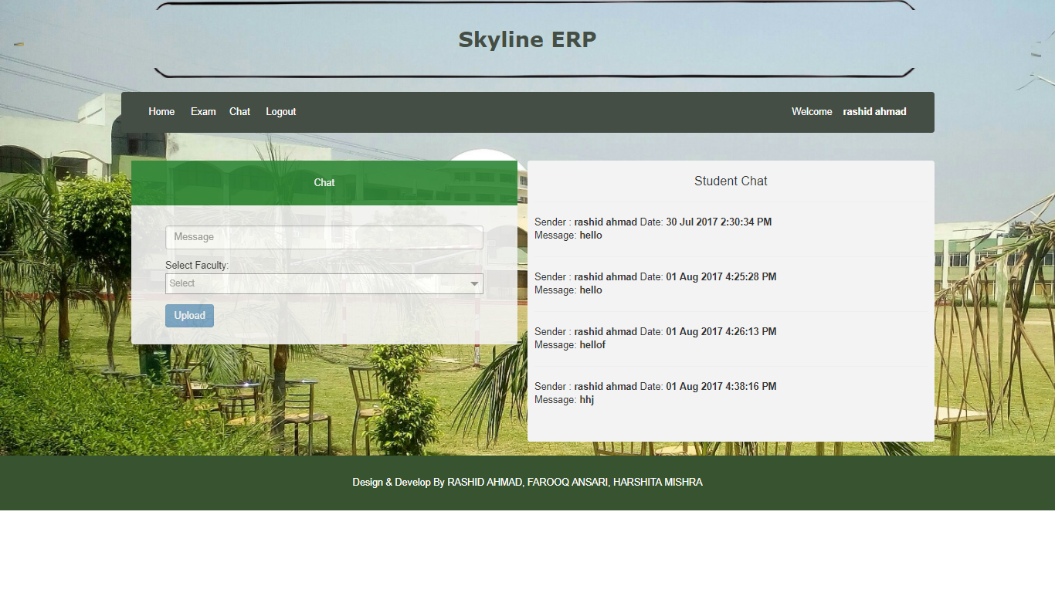

* STUDENT EXAM SECTION

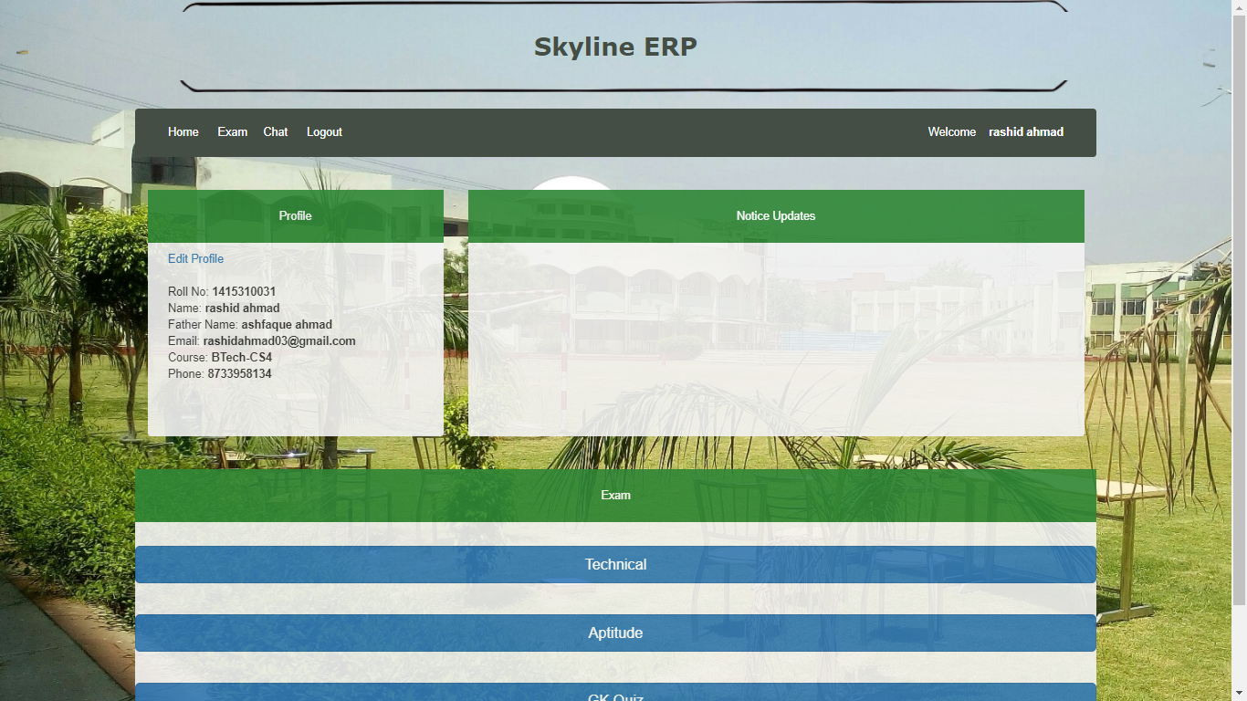

* STUDENT EXAM NOTICES

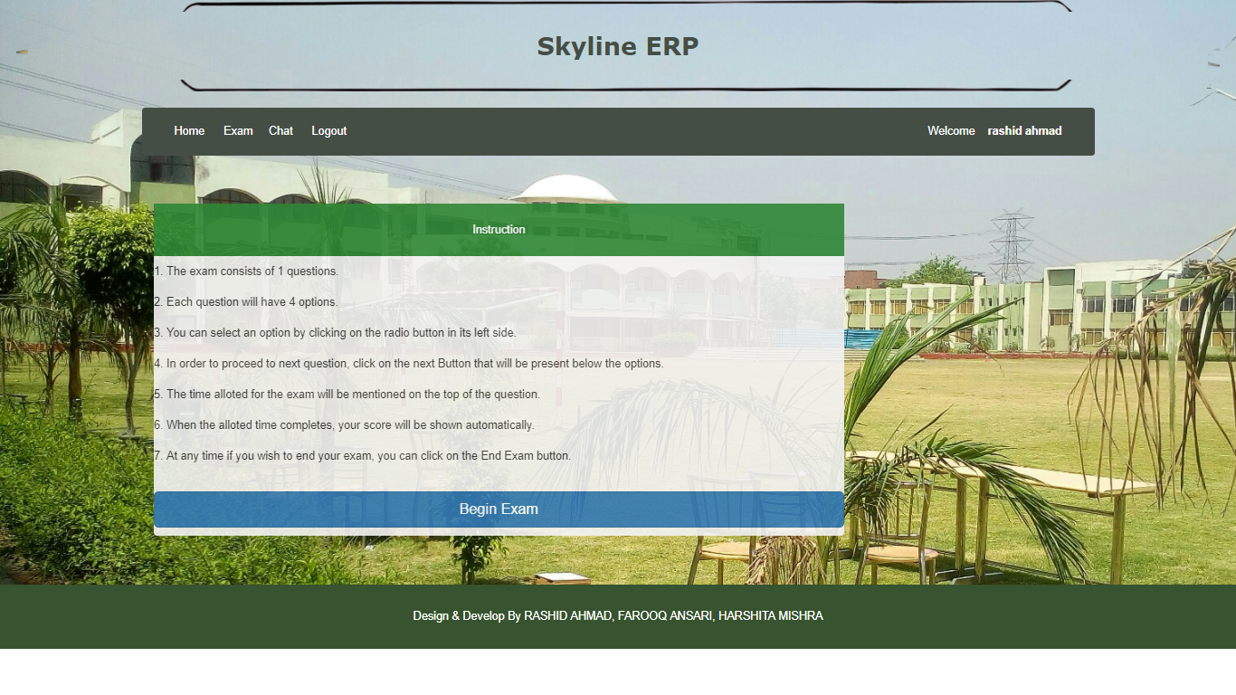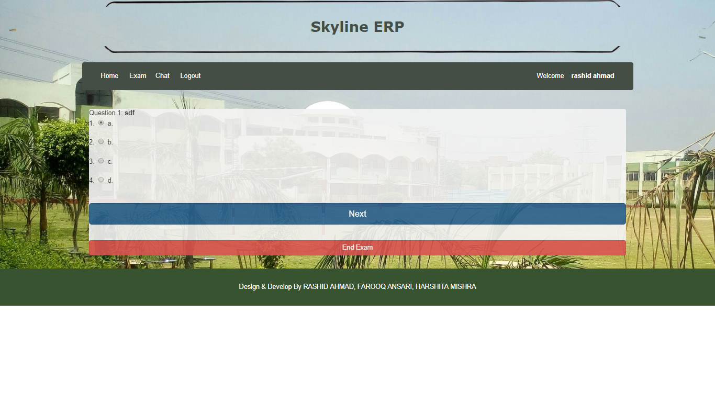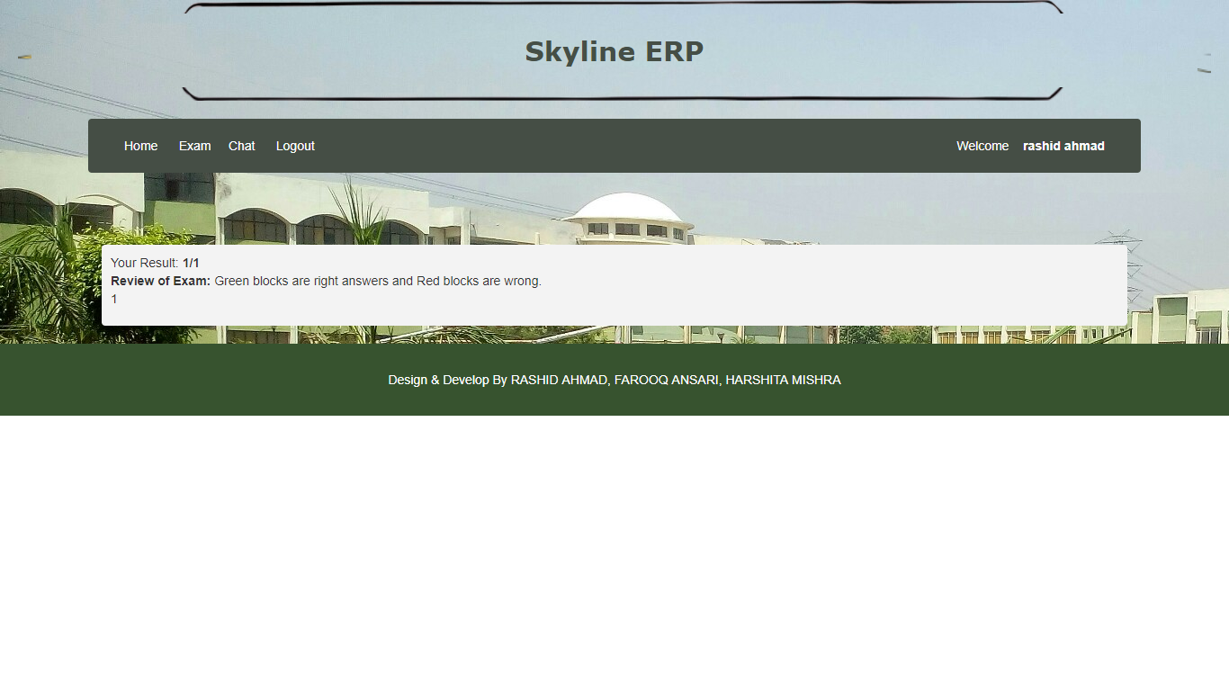

* STUDENT EDIT PROFILE

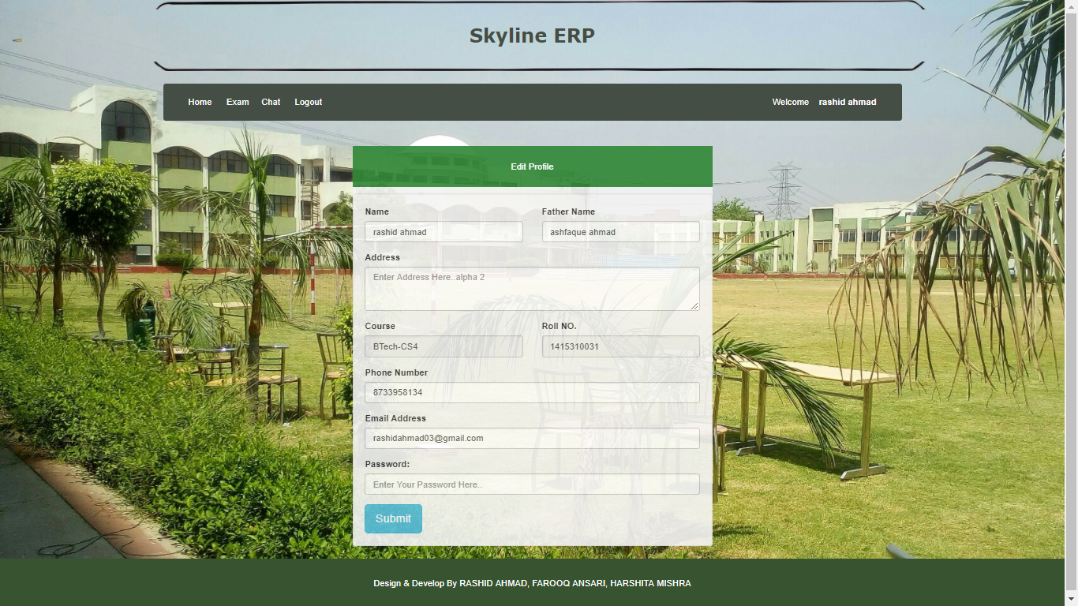

**CHAPTER-4**

**4.1 TESTING AND DEBUGGING**

There are the following rules can serve well as testing objectives.

* Testing is a process of executing a program with the internet of finding an error.
* A good test case is one of that has a high probability of finding an as-yet-undiscovered error.
* A successful test is one that uncover as-yet-undiscovered error.

**4.2 TESTING OBJECTIVES**

* To make sure that system meets the user requirements during operations .
* To ensure that during operation the system will perform as per specification.
* To make sure that during the operations incorrect input, processing and output will be detected.
* To see when the correct input are feed into the system the outputs are correct.
* To verify that the controls incorporated in the same system as intended.
* Testing is a process of executing a program with the intent of finding the error.
* A good test case is one that has a high probability of finding an error as yet undiscovered error .

The software developed has been tested successfully using the following testing strategies and any errors that are encountered are corrected and again the part of the program of the procedure or function is put to testing until all the error are removed. A successful test is one that uncover an as yet undercover error. Note that the result of the system testing will prove that the system testing that the system is working correctly. It will give confidence to system designer user of the system , prevent frustration during implementation process etc.,

**4.3 TESTING STRATEGIES**

* **UNIT TESTING**

In unit testing I have testing a single program module in an isolated environment. Testing of the processing is the main focus. Integration Testing Because of interface among the system module, we use integration testing. In other words it ensure that the data moving between the module is handled as intended.

* **SYSTEM TESTING**

During system testing the system is used experimentally to ensure that the software does not fail i.e. it will run according to its specification and in the way user expert. Special test data run input are input for the processing and the result examine. A limited number of users try to use it in unforeseen ways. It is preferable to discover any surprise before the organization implement the system and depend upon it.

In many organization persons other than those who wrote the original program to ensure more complete and unbiased testing and more reliable testing.

The norms that were followed during the phase were that after the developer of the software has satisfied regarding every aspect of the software under consideration he is required to release the program source code. A setup name release is used to copy the name file from the developers user area to a project area in the directory named with developer user name . here the entire final testing used to be done by other than the developer himself. If some change were desired in the program the developer were required to use another setup. Retrieve, which copied back the latest version of the program to developer areas.

As in this system data is entered at the different level I considered providing various types of checks like range check, validity, completeness check etc, in different data entry screen according to the requirements.

Since the user are not familiar to the new system the data screens were designed in such way that were:

* Consistent
* Easy to use
* Has a fast response time

System testing is the testing of the system against its initial objective. It is done either in a simulated environment or in live environment.

* **TEST REVIEW**

Test reviews attempts to verify that protection mechanism built into a system will, in fact, protect it from penetration mechanism.

**4.4TYPES OF TESTING TECHNIQUES**

* WHITE BOX TESTING
* BLACK BOX TESTING
* **WHITE BOX TESTING**

White box test focuses on the program control structure. Test cases are drive to ensure that all statement in the program has been executed at least once during testing and that all logical condition has been exercised. Basic path testing, a white box testing, makes use of program graph to drive the set of linearly independent test that will ensure coverage.

* **CODING TESTING**

Condition testing is test case design is probably for compound contain in a program modules. A simple condition is a Boolean variable or a relation expression.

* **BRANCH TESTING**

I have used branch testing that is probably for compound condition, the true and false for each branch.

* **DATA FLOW TSETING**

I have used data flow testing due to check the path of program according to the location of definition and used of variables in the program.

* **LOOP TESTING**

In our project I have used only simple loop. And I have use m pass through the loop where m<n.

* **BLACK BOX TESTING**

Black box testing focuses on the functional requirement of the software. That is, black-box testing enable the software engineer to drive set of input condition that will fully exercise all functional requirement for a program.

* **GRAPH-BASE TESTING METHOD**

I have used graph-based testing method for removing errors associate with relationship. The first step in this testing is to understand the abject that are modelled in software and the relationship that connect these objects.

* **EQUIVALENCE PARGTITIOING**

This testing is used for the following reasons:

* Specific numeric values
* Range of values
* Set of related values
* Boolean condition

* **BOUNDARY VALUE ANALYSIS**

Boundary value analysis is a test case design technique that complements equivalence partitioning. Rather than selecting any element of equivalence ERP the selection of test cases at the edge of the ERP. Rather than focusing solely on the input condition,

The point of equivalent partitioning as:

* An input condition specific a range boundary by value a and b, test cases should be design with value a and b and just a above and just below a and b.
* An input condition specific a number of values, test cases should be developed that exercise the minimum and maximum number.
* **ACCEPTENCE TESTING**

When the function test was complete, we involved the user to make sure that the system worked according to the users expectation. Thus the user did the final acceptance test

**4.5 IMPLEMENTATION**

The major part of the project is designed and developed by using Advance Java. But in future JSP will be incorporated to enhance the performance of the project. It will be evaluated and maintained by our own server and package. User Id validation and implementation is also a future application, which will be incorporated.

Optimization though is age-old concept but is a principal motive to be achieved, for this each and every module is tested in isolation to check its workability and participation in the project.

The system has been developed for the given condition and is found effectively. The developed system is flexible and changes can be made easy. Using the facilities and functionalities of JSP, the software has been developed in a neat and simple manner, thereby reducing the operators work.

The speed and accuracy are maintained in proper way. This user friendly nature of this software developed in JSP is very easy to work with both for the students as well as the faculty members with little knowledge of computer.

The system was verified with valid as well as invalid manner, the system is run with an insight into necessary modifications that may require in the future. Hence the system can be maintained successfully without much work.

**4.6 MAINTENANCE**

System maintenance denotes many changes made to a software services after it has been delivered to the organization. Maintenance is inevitable for almost any kind of product. However, most services need maintenance due to the wear and tear caused by use. On the other hand, software services do not need maintenance on this count, but need maintenance on this count, but need maintenance to correct errors, enhance features, port to new platforms, etc.

Software maintenance is becoming an important activity of large number of organizations. This is no surprise , given the rate of hardware obsolescence, the immortality of a software product per se, and the demand of the user community to see the existing software services run on newer platforms, run in newer environments, and/or with enhanced features. When the hardware platform changes and a software service perform low-level functions, maintenance is necessary. Also, whenever the support environment of a software changes, the software product requires re-work to cope with the newer interface. Thus, every software services continues to evolve after its development through maintenance efforts.

Maintenance covers a wide range of activities including correcting, coding and designing errors, updating documentation and test data and upgrading user support. Enhancement means adding, modifying or re-developing the code to support changes in the specifications. It is necessary to keep up with changing user needs and the operational environment. The software is designed with the view of easy updating to the software. Future advancements can be done easily through the review of services. The software architecture is strong enough to provide enhancement in functionality , performance and reliability. Functions in the software are designed in such a way that they dynamically update on addition of new and revised modules. To append new features in this software , the databases for student details, examination details are sufficient enough for the task. Thus the software is capable enough of being enhanced easily whenever requires by the user.

**4.7 FUTURE SCOPE OF PROJECT**

The major part of the project is designed and developed by using Advance Java. But in future JSP and active server pages will be incorporated to enhance the performance of the project. It will be evaluated and maintained by our own server and package. User Id validation and implementation is also a future application which will be incorporated.

Optimization though is the age-old concept but is a principal motive to be achieved, for this each and every module is tested in isolation to check its workability and participation in the project.

This project would be very useful for educational institutes where regular evaluation of students’ is required. Further it can also be useful for anyone who requires feedback based on objective type responses. Apart from this examination aspect, this project would be very useful for the placement department of the institutes to efficiently handle the student data in database that at present is maintained in the form of excel sheets manually.

**CHAPTER-5**

**5.1 CONCLUSION**

The system has been developed for the given condition and is found working effectively. The developed system is flexible and changes can be made easily. Using the facilities and functionalities of JSP, the software has been developed in a neat and simple manner, thereby reducing the operators work.

The speed and accuracy are maintained in proper way. The user friendly nature of this software developed in JSP is very easy to work with both for students as well as faculty members with little knowledge of computer.

The system was verified with valid as well as invalid data in each manner, the system is run with an insight into the necessary modification that may require in the future. Hence, the system can be maintained successfully without much network

Current system provides only multiple choices but single correct answer selection. Faculty may wish to provide multiple choices multiple selection responses.

In case questions and/or answers need to be in graphics, current system has no provision.

Unregistered users cannot answer test. This is a drawback in case the faculty wants anyone even anonymous users to answer the test.

The system currently maintains backups on the same system on which the database server is running and as a result is susceptible to hardware failures and needs to be looked at in the next version.

**5.2 APPENDICES**

**5.2.1QUESTION SELECTION ALGORITHM:**

The software makes use of a carefully crafted and well analysed algorithm for selecting questions from the database such that they are random. The software makes use of the random number generator in java.util.Random for generating the random q ids and the corresponding random indices.

**5.2.2 ALGORITHM**:

**Input parameters:** No of questions to be marked N, type of questions table.

**Returns:** The fetched questions array from the database

1. Mark all previously marked questions in the corresponding table used.
2. Count the total unused questions from the corresponding table,

available=getUnusedQuestions(table).

1. Get the total number of available questions from the database.

total=getTotalQuestions(table).

1. Check to see if there are enough questions as required.

If(total>=N)

then

if(available <N)

then mark all used questions as unused.

Next get the max available qid in the corresponding table:

max=max(qid) from table.

Initialize an array questions[] of length N.

Initialize i=0, j=0

while i < n do

next=get nextRandom qid less than max;

if a question with the qid exists then add then get the question with this qid

then.

Q=getQuestion(next)

Choose a random index j into the array where to fill this question.

Do{

j=getNextRandom index < N.

}while arr[j] is found occupied.

Next fill the question at the index obtained.

arr[j]=Q.

i=i+1;

else continue.

Return the questions array fetched.

Else return error: Not enough questions in the database.

**CHAPTER-6**

**6.1 REFERENCES**

**6.1.1BOOKS**

* Java: The Complete Reference by Herbert Schildt.
* JavaScript: The Definitive Guide by O’Reilly.
* HTML and CSS: Design and Build by Jon Duckett.
* Fundamentals of Database Systems, Elmasri, Navathe.
* Object Oriented Design using UML, M. Blaha et al
* Java Programming Language, James Gosling et al
* JSP 2.0 specification, <http://java.sun.com>, http:\\www.jcp.org
* Java 1.6 API, http://download.oracle.com\javase\6\docs\api\
* http://w3schools.com
* Sedna native XML <http://modis.ispras.ru>
* UML official website http://www.uml.org/
* Star UML - The Open Source UML/MDA Platform http://staruml.sourceforge.net/

**6.1.2 VIDEOS**

* Java videos from [www.thenewboston.com](http://www.thenewboston.com) by Bucky Roberts.
* [www.tutorialspoint.com/java](http://www.tutorialspoint.com/java)
* JavaScript videos from [www.thenewboston.com](http://www.thenewboston.com) by Bucky Roberts.